

SYSTEMS ANALYSIS AND DESIGN 1

PROJECT A5MMS

Use Case Diagram and Narrative Description

Lopez, Carlucenne

Naperi, Jayson

Dela Cuesta, Georgette

Rocero, Earl Jerome

**Team Members**

Ms. Rhea Luz Valbuena

**Professor**

USE CASE DIAGRAM

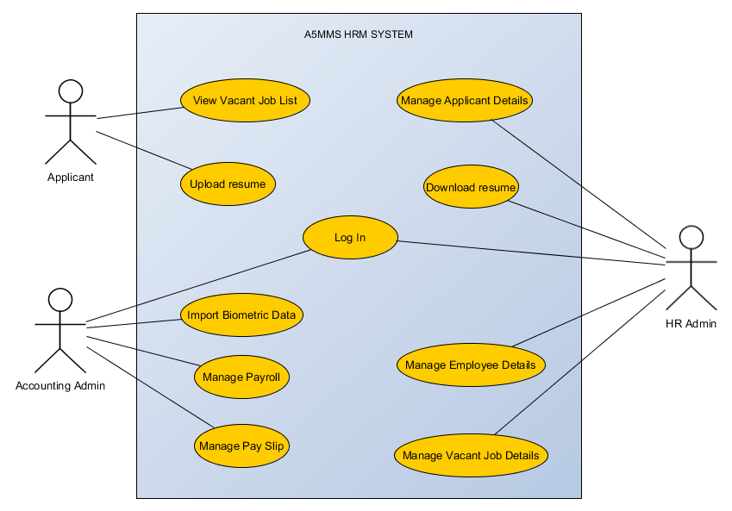

USE CASE NARRATIVE DESCRIPTION

|  |  |
| --- | --- |
| USE CASE NAME | View Vacant Job List |
| ACTOR | Applicant |
| DESCRIPTION | Describes the process in viewing the list of the job in the website |
| SUCCESSFUL COMPLETION | 1. Applicant access the system 2. System displays list of vacant jobs 3. Applicant selected desired vacant job 4. System displays details of vacant job 5. Applicant will view the details of the vacant job |
| ALTERNATIVE | * 1. Applicant can walk – in to the agency for the vacant job details if he can’t access the system   5.1 Applicant search for another job online if he/she doesn’t like the listed vacant jobs in the system |
| PRE – CONDITION | Applicant searching for a job |
| POST – CONDITION | Applicant selected desired job to apply |
| ASSUMPTION | List of vacant job and details will be viewed in the system |

|  |  |
| --- | --- |
| USE CASE NAME | Upload Resume |
| ACTOR | Applicant |
| DESCRIPTION | Describes the process of submitting resume in the system |
| SUCCESSFUL COMPLETION | 1. Applicant will input his/her personal information and upload resume to the selected job 2. System will prompt message if the inputted information are correct 3. Applicant will click button if yes or no 4. If yes, the information will be automatically inserted in to the database of the system 5. System prompts and displays the final information he/she inputted |
| ALTERNATIVE | * 1. Applicant can walk – in to the agency for them to send resume to the job he/she were applying for and the HR admin will manually encode the information of the applicant in the system.   2. Applicant can submit resume through e-mail and the HR admin will manually encode the information of the applicant in the system.   3.1 If no, the applicant will edit his/her inputted information |
| PRE – CONDITION | Applicant selected a job to apply |
| POST – CONDITION | Successful submission of resume and applicant information |
| ASSUMPTION | Applicant selected a job to apply |

|  |  |
| --- | --- |
| USE CASE NAME | Log – In |
| ACTOR | HR Admin / Accounting Admin |
| DESCRIPTION | Describes the process of logging – in to the system |
| SUCCESSFUL COMPLETION | 1. Admin enters username and password and clicks ‘Log-in’ 2. System verifies the account 3. System prompts account validity 4. Admin successfully access the system |
| ALTERNATIVE | * 1. If the process of logging in of the admin fails, he/she can create another admin account |
| PRE – CONDITION | Admin accessed the system |
| POST – CONDITION | Admin successfully log in to the system |
| ASSUMPTION | Admin has already an account |

|  |  |
| --- | --- |
| USE CASE NAME | Manage Applicant Details |
| ACTOR | HR Admin |
| DESCRIPTION | Describes the process in managing the applicant list |
| SUCCESSFUL COMPLETION | 1. HR Admin selects applicant module 2. System displays agency’s clients 3. HR Admin selects a client 4. System display applicants details and uploaded resume applied to that client 5. HR Admin manages applicant details 6. System display updated applicants details 7. HR Admin views applicants details and uploaded resume |
| ALTERNATIVE | 3.1 HR admin will manually encode the information of the applicant in the system, if the applicant applied walk – in to the agency |
| PRE – CONDITION | Applicant input information and uploaded resume |
| POST – CONDITION | HR Admin updated applicant details |
| ASSUMPTION | Applicant submitted resume |

|  |  |
| --- | --- |
| USE CASE NAME | Downloads Resume |
| ACTOR | HR Admin |
| DESCRIPTION | Describes the process in downloading applicants resume |
| SUCCESSFUL COMPLETION | 1. HR Admin selects applicant module 2. System display list of applicants and uploaded resume 3. HR admin selects an applicant’s resume 4. System display applicant’s uploaded resume 5. HR admin select download resume 6. System will download resume 7. HR Admin prints the downloaded resume |
| ALTERNATIVE | 3.1 HR Admin remains the resume store in the database or in the system |
| PRE – CONDITION | HR Admin selected an applicant resume |
| POST – CONDITION | HR admin printed applicant resume |
| ASSUMPTION | Applicant submitted resume |

|  |  |
| --- | --- |
| USE CASE NAME | Manages Employee Details |
| ACTOR | HR Admin |
| DESCRIPTION | Describes the process in managing the employee details |
| SUCCESSFUL COMPLETION | 1. HR Admin selects employee module 2. System displays agency’s clients 3. HR Admin selects a client 4. System displays employees details working on that client 5. HR Admin input/manages employee details in a specific client 6. System display updated employee details 7. HR Admin views updated employee details |
| ALTERNATIVE | 3.1 HR Admin contact/personally meet client regarding on the employee details |
| PRE – CONDITION | Client sent employee details |
| POST – CONDITION | HR Admin updated employee details |
| ASSUMPTION | HR Admin received the employment details from client |

|  |  |
| --- | --- |
| USE CASE NAME | Manages Vacant Job Details |
| ACTOR | HR Admin |
| DESCRIPTION | Describes the process in managing the vacant job details |
| SUCCESSFUL COMPLETION | 1. HR Admin selects vacant job module 2. System displays agency’s clients 3. HR Admin selects a client 4. System displays vacant job details offered by that client 5. HR Admin input/manages vacant job details in the system sent by the client 6. System updated vacant job 7. HR Admin views updated vacant job in the system |
| ALTERNATIVE | 3.1 HR Admin contact/personally meet client regarding on the vacant job details |
| PRE – CONDITION | Client sent vacant job details |
| POST – CONDITION | HR Admin updated vacant job details in the system |
| ASSUMPTION | HR Admin received the vacant job details from client |

|  |  |
| --- | --- |
| USE CASE NAME | Import biometric data |
| ACTOR | Accounting Admin |
| DESCRIPTION | Describes the process in importing biometric data |
| SUCCESSFUL COMPLETION | 1. Accounting Admin selects payroll module 2. System displays agency’s clients 3. Accounting Admin selects a client 4. System displays import form of the biometric data 5. Accounting Admin imports/manages biometric data in specific client 6. System prompts message for the successful import |
| ALTERNATIVE | 3.1 Accounting Admin contact/personally meet client regarding on the biometric data  3.2 Accounting Admin can manually input the employees working details on a specific client in the system, if the data that the client sent was not supported by the system to import. |
| PRE – CONDITION | Client sent biometric data |
| POST – CONDITION | Accounting Admin successfully imported biometric data in the system |
| ASSUMPTION | Accounting admin received the biometric data from client |

|  |  |
| --- | --- |
| USE CASE NAME | Manages Payroll |
| ACTOR | Accounting Admin |
| DESCRIPTION | Describes the process in managing payroll |
| SUCCESSFUL COMPLETION | 1. Accounting Admin selects payroll module 2. System displays agency’s clients 3. Accounting Admin selects a client 4. System displays employees’ working details from the biometric data working on that client 5. Accounting Admin clicks compute payroll 6. System automatically computes payroll for that particular client’s employees 7. Accounting Admin manages the computed payroll details 8. System displays updated payroll 9. Accounting Admin views updated payroll details |
| ALTERNATIVE | 1.1 Accounting Admin manually input and manage payroll if the biometric data sent by the client are not supported by the system |
| PRE – CONDITION | Accounting admin imported biometric data |
| POST – CONDITION | Accounting Admin computed and updated payroll |
| ASSUMPTION | 1. Accounting admin imported the biometric data from client 2. Biometric data should be supported by the system in terms of file format. |

|  |  |
| --- | --- |
| USE CASE NAME | Manages Pay Slip |
| ACTOR | Accounting Admin |
| DESCRIPTION | Describes the process in managing pay slip |
| SUCCESSFUL COMPLETION | 1. Accounting Admin selects pay slip module 2. System displays agency’s clients 3. Accounting Admin selects a client 4. System displays employees of that client 5. Accounting Admin selects an employee 6. System displays employee’s pay slip from the computed payroll 7. Accounting Admin prints the employee’s pay slip |
| ALTERNATIVE | Manual management and computation of payroll |
| PRE – CONDITION | Accounting admin computed and updated payroll |
| POST – CONDITION | Employee received the printed pay slip |
| ASSUMPTION | Accounting admin computed and updated payroll |